|  |  |
| --- | --- |
| Name | Ritankar Ganguly |
| Batch | MS FSD DEC 2021 Cohort 1 |
| Submission Date | 31/3/2022 |
| Project Title | Learner’s academy (Phase 2 Final Project) |

Screen Shots:

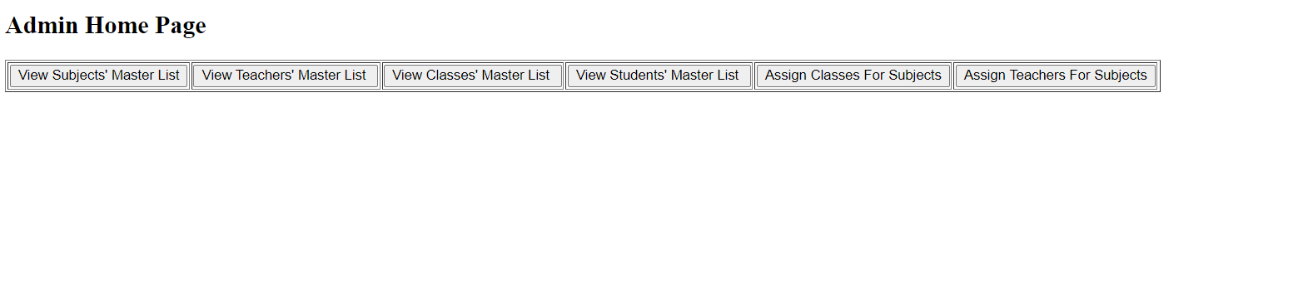

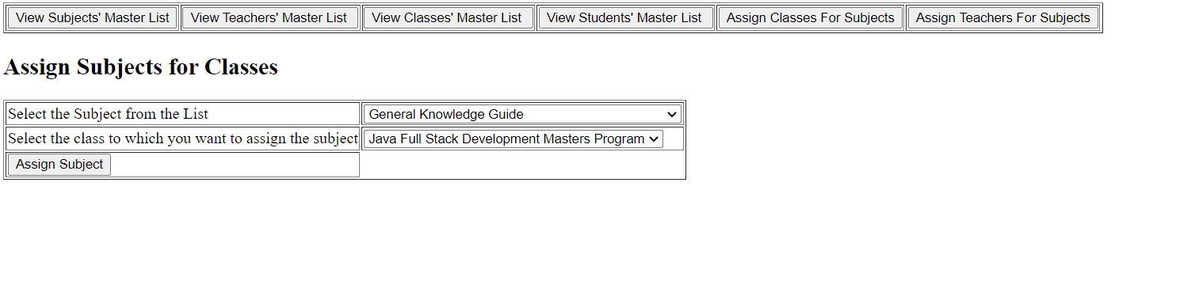

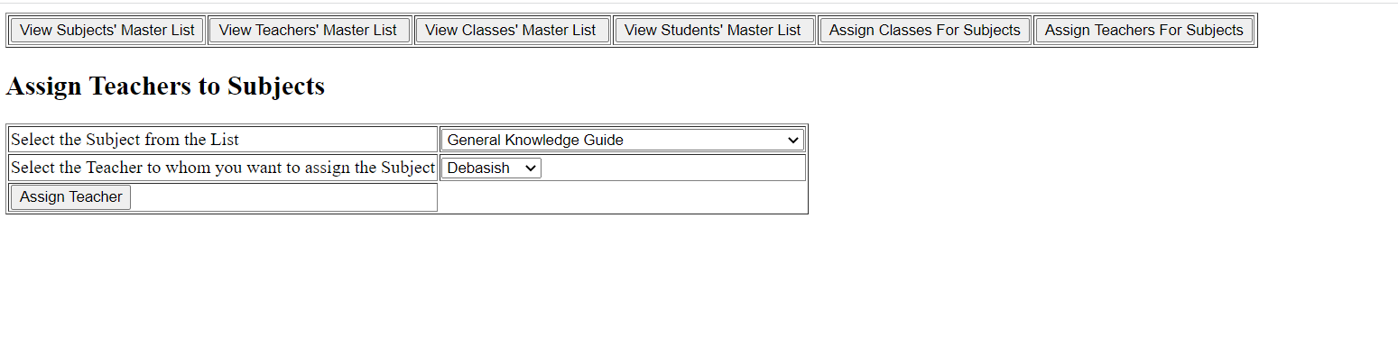

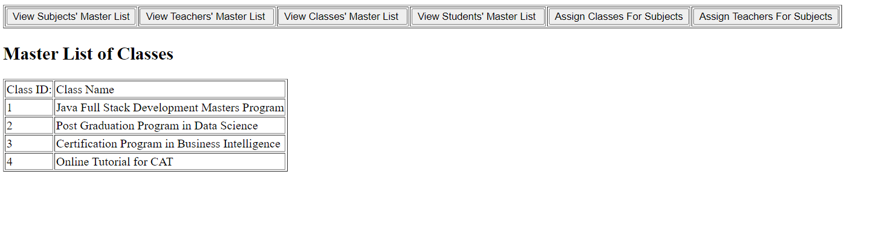

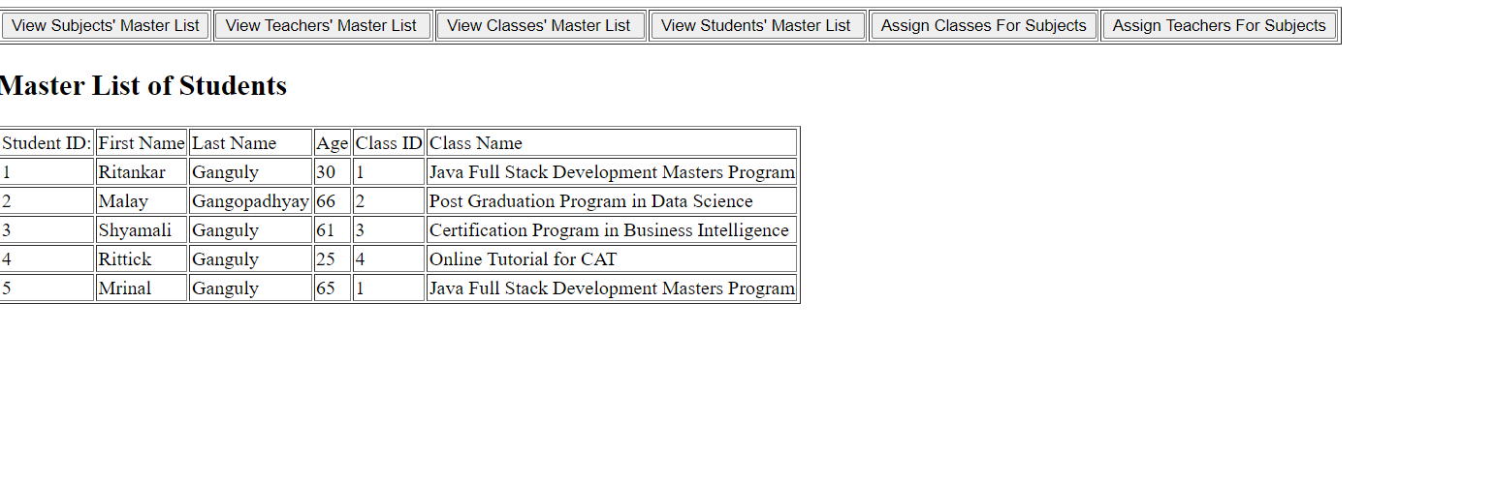

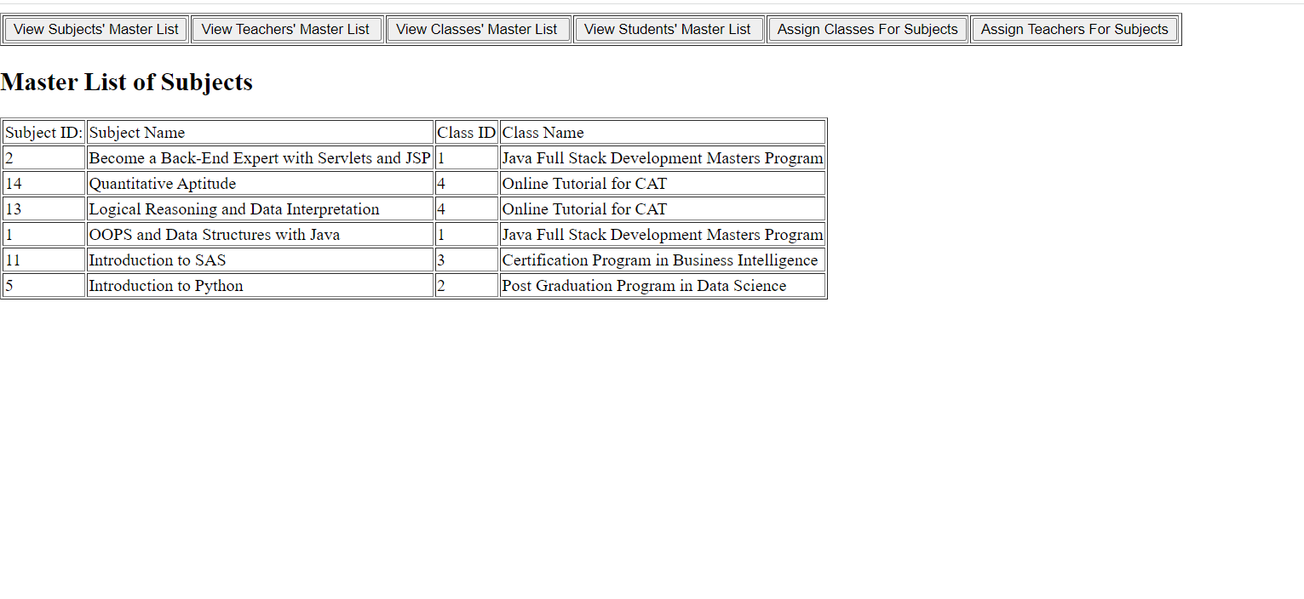

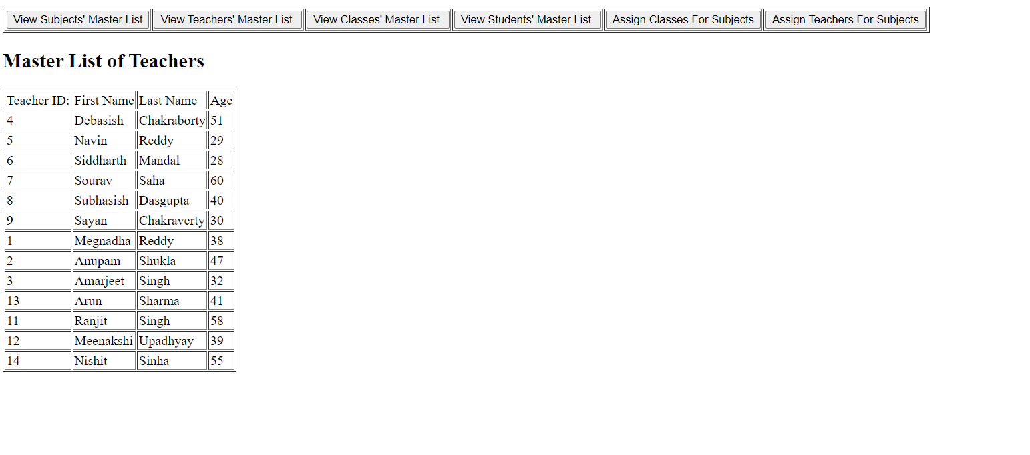

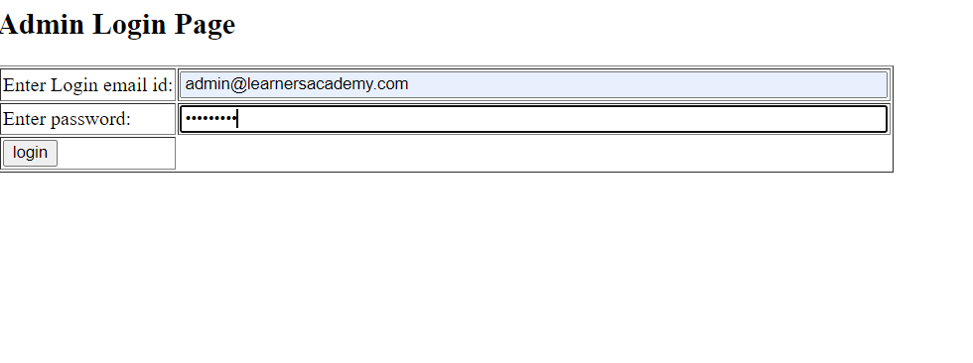

**Classes Table**

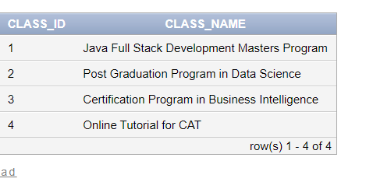

**Students Table**

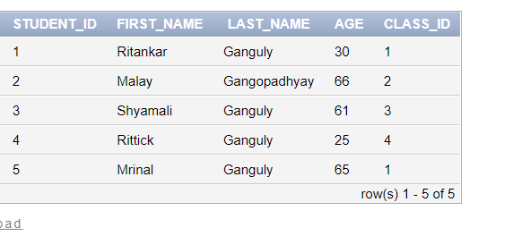

**Subject_Class table**

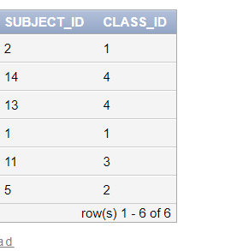

**Subject_Teacher Table**

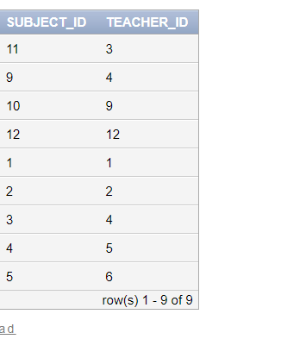

**Subjects Table**

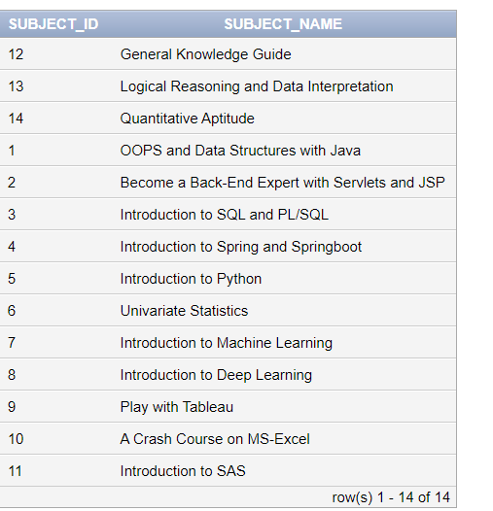

**Teachers Table**

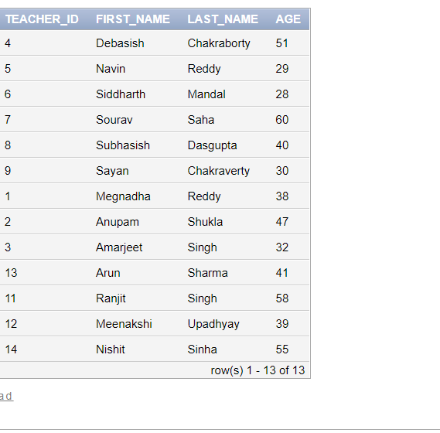

**Users Table**

